**IOT-Based crop monitoring**

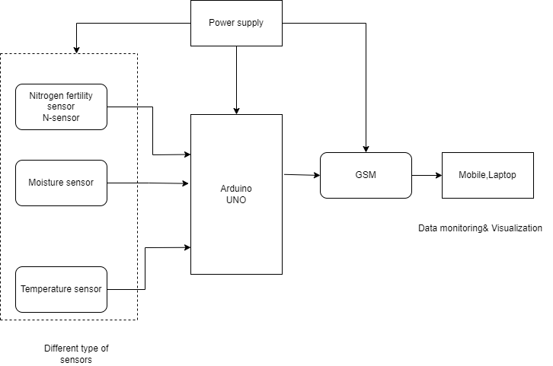

With the help of a variety of approaches, including precision farming and sustainable agriculture, the Internet of Things (IOT) is revolutionizing agriculture and empowering farmers to overcome obstacles in the field. Information about weather, moisture, temperature, and soil fertility is collected using IOT technology. Online crop monitoring makes it possible to detect weeds, water levels, pests, animal infiltration into the field, crop growth, and agriculture.

To gather data on crop conditions and environmental changes, wireless sensor networks and sensors of various kinds are utilized. This data is then transferred through networks to the farmer or equipment that start corrective operations. The captured data are displayed on a laptop or a smartphone. It is possible to determine which areas will produce good crops and which ones require more care.